Name_________________________________ Period _____________ Date ________________



**Lesson 7: How Does the Amount of Vegetation on Earth Affect Climate?**Rainforests currently cover about 6% of the land on Earth, down from about 15% in 1950. The forests provide a wealth of beneficial substances. They also remove carbon dioxide from the air and use it to photosynthesize.

**Doing the Science**

1. Start the Weather/Climate simulation.

2. Click the "Change Factors" button.

3. Select "Rainforest Coverage" from the "Choose Factor" pull-down menu.

1. Select "+15%" from the "0%" pull-down menu. Click the "Apply change" button.
2. Click the "Spin" button.
3. A red icon indicates an increase in temperature of 0.1 ºF. A blue icon indicates a decrease in temperature of 0.1 ºF. The green dot in the graph at the top of the screen displays the net change in temperature over the 30-year period. Record your data in the graph below.
4. To speed the spin rate up, click on the green "Faster" icon next to the "Spin" button.
5. Repeat steps 5 and 6 until you complete a total of 20 spins.
6. Make sure to record your data in the graph below.

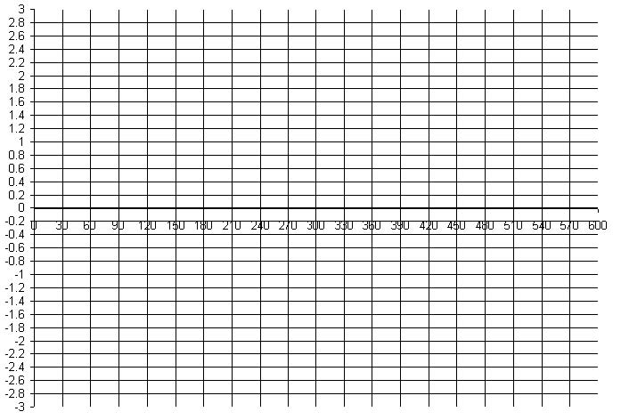

Temperature difference from average yearly temperature (in °F.)

Number of years

**Do You Understand?**

1. Was the graph of the temperature data showing above average, average, or below average temperatures during most of the 600 years of data?
2. Based on temperature, was the climate changing in the area over which the temperature data were collected? Discuss your reasoning for your response.
3. Change the percentage of rainforest coverage by repeating step 4. Make sure to select a different % value in step 4. Repeat steps 5 -9. Discuss how the average temperature changed as a result of this new percentage of rainforest coverage. Write a generalization as to how global temperature is affected by the amount of land covered by rainforest.